* **Activity 2:**

### Using the COUNT Function

**Display the number of flights in the "International" category and the number of flights in that category with a ticket price defined (not NULL).**

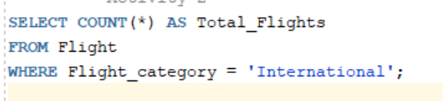

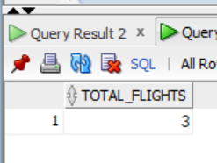Output:

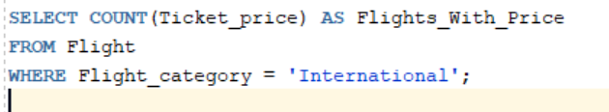

Output:

